PD Session: Using Powerpoint for Poster Creation
Speaker: Pam Truesdell, Resource Member for CEEMS University of Cincinnati
Date: Tuesday, July 11, 2017
Time: 9:00am-11:00am
Venue: University of Cincinnati, Swift Hall, room 516
Prepared by:
Todd Hamilton, Academy of World Languages Elementary, Cincinnati, Ohio
RET Participant for project #1 “Characterization and Synthesis of Cu Nanoparticles”

Summary
This session was given by Pam Truesdell, resource member for CEEMS at the University of Cincinnati on Tuesday, July 11, 2014 from 9:00am to 11:00 am at the University of Cincinnati in Swift Hall, room 516. Ms. Truesdell was a teacher for 30 years at Western Hills High School in Cincinnati, and a participant of the Albert Einstein Distinguished Educator Fellowship. Ms. Truesdell is also the author of “Engineering Essentials for STEM Instruction”, a short book that outlines ways to infuse real world problem solving into math and science classrooms. Figure 1 shows a copy of Ms. Truesdell’s book.

Ms. Truesdell began the session with a brief background in her teaching history and her qualifications for leading the PD session on using Powerpoint to create academic posters. Throughout Ms. Truesdell’s 30-year career as a teacher she taught computer science. Teaching computer science required Ms. Truesdell to often teach software programs like Powerpoint, and Excel. Figure 2 shows a photograph of Ms. Truesdell and some of her titles and accomplishments.

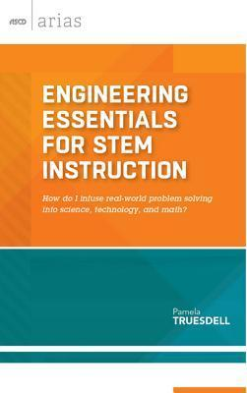
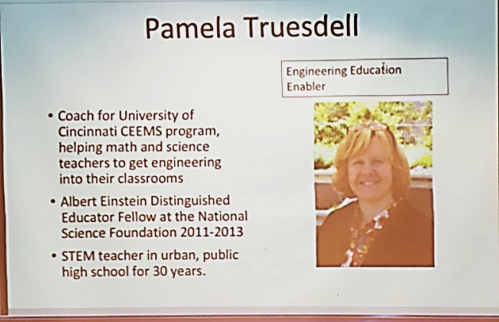
Figure 1: A Copy of Ms. Truesdell’s Book
Figure 1: A Copy of Ms. Truesdell’s Book

http://ebusiness.ascd.org/serverfiles/productimages/sf114048b.jpg
http://www.ascd.org/ASCD/images/siteASCD/people/truesdell-p120x148.jpg
Figure 2: A Photo of Ms. Truesdell with a Description of Accomplishments

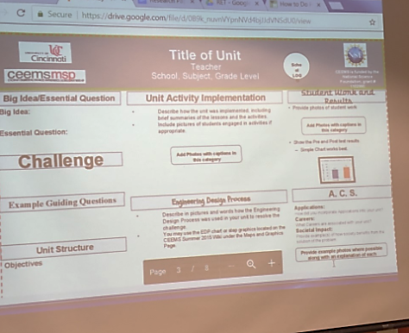
After Ms. Truesdell’s introduction, RET participants were shown sample posters. Each poster contained components of good and bad examples. Figure 3 shows an example of a poster RET participants fixed. RET participants were tasked to choose which components were bad examples of poster strategies and which were good examples. After the RET participants identified the bad examples shown in the posters each team began to identify how these problems could be fixed. Ms. Truesdell collected the opinions of each team on how the poster could be improved. After each teams input, Ms. Truesdell began to show ways to change and alter the problems using Powerpoint’s software.
Figure 3: An Example Poster with Errors

When all poster examples were analyzed and fixed for completeness, Ms. Truesdell then asked all RET participants to identify some troubles they have while using Powerpoint. RET participants created a short list of things they would like to be able to do using the Powerpoint software. Some participants seemed to be knowledgeable on many of the ways Power Point could be used. Ms. Truesdell went over some simple tricks to help clarify problems with RET teachers. Ms. Truesdell then acknowledged the RET participant’s skills in using Powerpoint and began to go deeper into the many functions that Powerpoint offers. RET participants were shown how to change web images to clearly fit the backgrounds of their posters. Ms. Truesdell was able to manipulate images from the web to eliminate image backgrounds that make images look foggy, tacky, or unclear. Ms. Truesdell was also able to clarify how to select images that would best show up on posters after printing. It was pointed out that many images look clear online, however, the pixels will not match color or clarity after poster are printed.
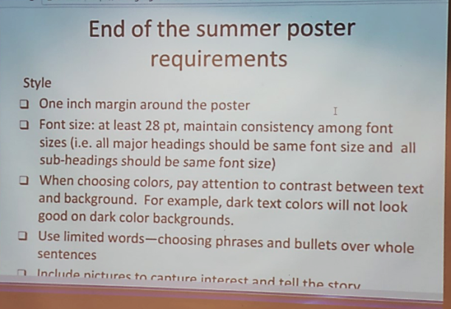
At the end of the session Ms. Truesdell went over formatting procedures when creating a presentation poster using Powerpoint. Ms. Truesdell used the function of Powerpoint to zoom in and out of particular sections of the slide. RET participants were shown alignment tools that would quickly align images, text, and other text box so posters were clear and east to read. Ms. Truesdell emphasized proper formatting to RET participants. Figure 4 shows the end of summer poster requirements shown by Ms. Truesdell. It was urged that each poster was given a good font and text size, that there wasn’t too much white space, and that the grant # be recognized clearly.

Figure 4: End of Summer Poster Requirements

